UID LAB EXPERIMENT - 3A
KARTHAVYA S

Food Ordering App

1. Introduction
This document provides a detailed breakdown of the Food Ordering App prototype. The design focuses on a vibrant, food-centric user experience, allowing users to browse authentic Indian dishes, manage favorites, and navigate a categorized menu seamlessly.

2. Objective of the Design
- Visual Appeal: Use high-quality imagery of Indian cuisine to stimulate user appetite.
- Streamlined Ordering: Create a frictionless path from the Splash screen to the Menu.
- Personalization: Demonstrate how users can "Favorite" specific items (like Biryani or Idly) for quick access.
- Clear Categorization: Organize diverse food items into logical time-of-day categories (Breakfast, Meals, Snacks).

3. Overview of the Prototype
The prototype features a warm color palette (burnt orange and white) to evoke a sense of spice and freshness. It utilizes a standard bottom navigation bar for high-level movement and a tab-based system for menu filtering.
Key Characteristics:
- Thematic UI: Warm orange accents consistently used for buttons and active states.
- Image-Driven Cards: Large, rounded cards that highlight the food aesthetic.
- Contextual Navigation: Use of "Back" buttons and a persistent Shopping Cart icon.

4. Design Structure

4.1 Welcome & Onboarding (Splash Screen)
- Visuals: Features an artistic illustration of spoons and spices.
- Action: A prominent "Get Started" button serves as the primary entry point.
- Bottom Graphic: A high-resolution "Thali" image sets the culinary tone immediately.
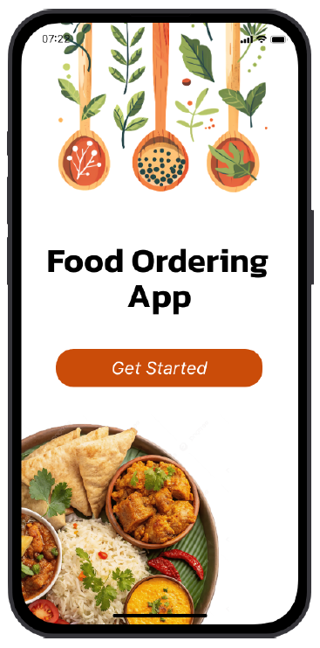

4.2 Home / Landing Screen
- Greeting: Personalized "We Welcomes You" header with a friendly Chef mascot.
- Quick Action: A secondary "Click here to see the Menu" button to drive user conversion.
- Visual Depth: Features a semi-transparent food background to maintain the theme without distracting from the text.

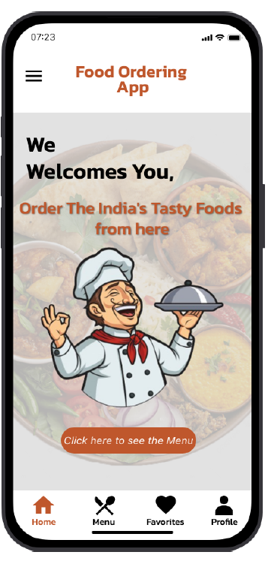

4.3 The "Our Menu" Experience
This section is split into three interactive tabs:
- Breakfast: Featuring South Indian staples like Idly, Dosa, Chapati, and Puri.
- Meals: Focused on heavier options like Full Meals and Chicken Biryani.
- Snacks: Highlighting popular street foods and appetizers like Pani Puri, Samosa, Sandwich, French Fries, and Momos.

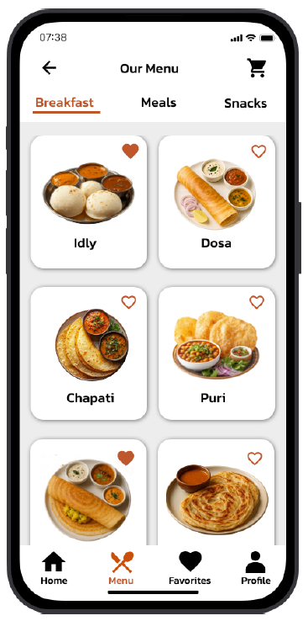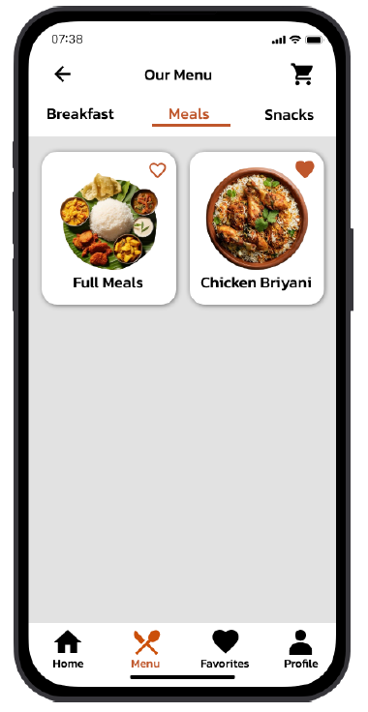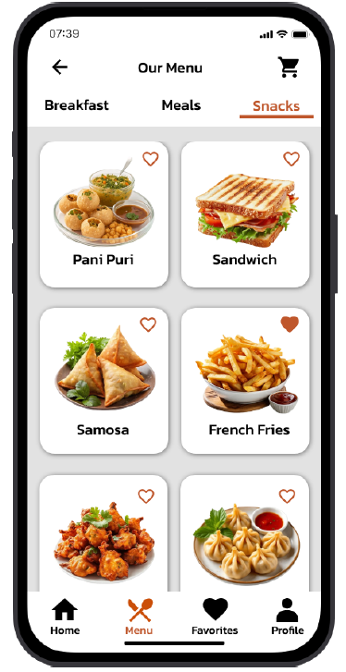

4.4 My Favorites Screen
- Allows users to view a curated list of their liked items.
- In the prototype, items like Chicken Biryani and Masala Dosa are shown with "filled" heart icons to indicate the active favorite state.
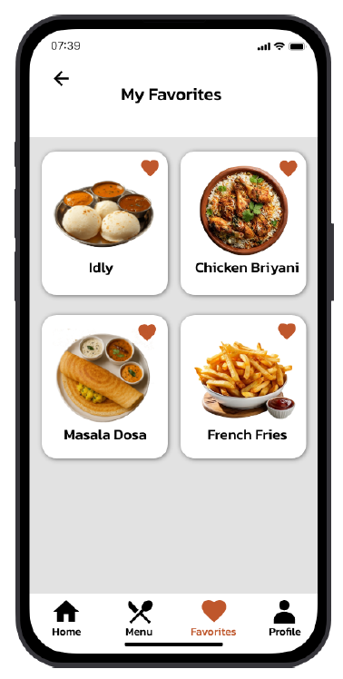

5. UI/UX Design Principles
- Visual Hierarchy: Bold typography for dish names and subtle grey backgrounds for cards to create depth.
- Feedback Loops: Changing heart icon states (outlined vs. filled) provides immediate visual feedback.
- Intuitive Layout: The bottom navigation uses recognizable icons (Home, Fork/Spoon for Menu, Heart for Favorites, Person for Profile).

6. Tools and Technologies Used
- Proto.io: For high-fidelity prototyping and transition logic.
- Custom Assets: Transparent PNG food photography and themed vector illustrations.

7. Advantages of the Prototype
- Stakeholder Alignment: Clearly shows how the "Meals" vs. "Snacks" categories will look.
- UX Validation: Confirms that the bottom navigation is the most efficient way to switch between the Menu and Favorites.

8. Future Enhancements
- Search Functionality: Adding a search bar to the "Our Menu" screen.
- Checkout Flow: Designing the "Cart" and "Payment" screens.
- Filter System: Adding Veg/Non-Veg filters to the menu cards.

9. Conclusion
The Food Ordering App prototype successfully translates the richness of Indian cuisine into a clean, modern mobile interface. By focusing on high-quality visuals and a logical category structure, this design provides a solid blueprint for the upcoming development phase.

